# **androidGO: An Introductory Course to Android App Development**

**Student Notes**

## Authors

## Akansha Patel

## Ketki Haridas

## Pallavi Santosh

## Shyama Sankar Vellore

# CURRICULUM

## COURSE OVERVIEW

This curriculum is designed to introduce software developers to the world of mobile app development. The course follows a modular structure that introduces the audience to the various elements of Android development, reinforcing the concepts covered in each modules using simple mini-projects. The final module of the course combines all the mini-projects designed in the previous modules to develop your very own version of an SOS applicaton.

## MODULE 1: INTRODUCTION TO ANDROID APPLICATIONS

The Android operating system functions a lot like a multi-user Linux system where each application is considered to be a user with its own virtual machine. Android applications can be developed on multiple platforms, ranging from code-oriented platforms like the Eclipse IDE to graphical platforms like the MIT App Inventor. This course focuses on developing applications on Android Studio, which is the official IDE for Android.

### Basic Terminology

These are some of the terms that are used extensively through the document:

1. Activity: This is the tangible interface of an application that the user interacts with. Activities run as foreground processes.
2. Services: These are background processes that do not have a tangible UI.
3. Fragments: Fragments are sorts of “sub-activities” that share resources within a single activity.
4. Widgets: I/O components that allow the user to interact with the application.
5. Intents: Intents are classes that abstract certain operations like starting activities/services, broadcasting messages, etc.

### The Project Structure of an Android App

1. Java based code: This part of the project consists of the Java-based code that implements the logic behind the functioning of the application. These codes define activities (the screens visible to the user), utility functions, etc.
2. The layout files: These are xml files that describe the layout and positioning of various UI elements on the app screen. All activities are required have an xml file associated with it.
3. Manifests: Manifests declare the permissions provided to the application that govern the types of device resources it can access. The ability to read/write to external storage, accessing in-built sensors, connecting to the internet, etc. are defined in the manifest files.
4. Other resources: These are xml files that contain miscellaneous resources like hard-coded strings, hex values for color, formatting styles, etc.

### Life Cycle of an Android Application



Source: <https://developer.android.com/training/basics/activity-lifecycle/starting.html>

When an application is launched from the application menu on a physical Android device, it goes through the following stages:

1. On launching the application, the main activity is created, i.e., the onCreate() method of the main activity is invoked.
2. The onStart() method is invoked when the activity becomes visible to the user.
3. The activity runs as described by the onCreate()/onStart()/onResume() method.
4. onPause() is invoked if the activity needs to be paused due to physical constraints of the system, example, memory, processing power, etc.
5. onStop() is invoked when the activity is not visible to the user anymore but the application is still running in the background.
6. onDestroy() is invoked when the activity is shut down. If the application consists of other activities, their respective onCreate() methods are invoke.

### Creating a New Project

1. Start up Android Studio.
2. Go to File -> New Project.
3. Input a cool name for your application.
4. Proceed to the next screen where you would select the target platform (depends on the features you would like to use, but API 19 usually does the trick).
5. Create an activity on the next screen and you have your first project!
6. This is what the Java code of a basic activity would like and the onCreate() method is where all the logic goes:

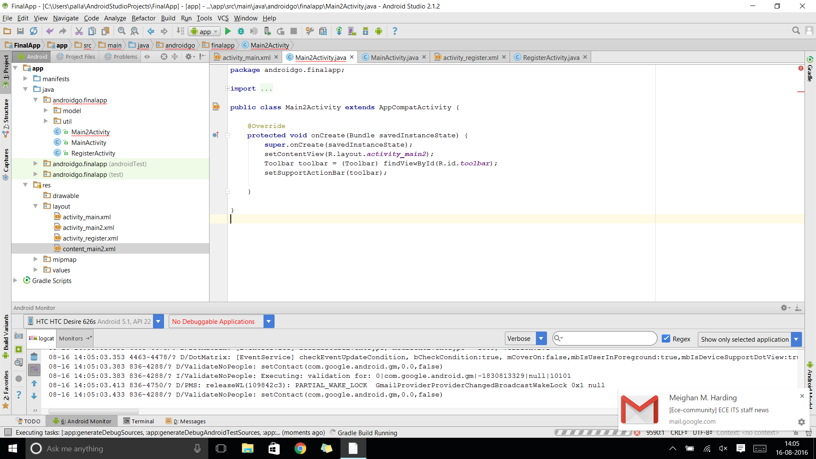

1. Use the graphical version of the layout files to add your design elements and widgets.

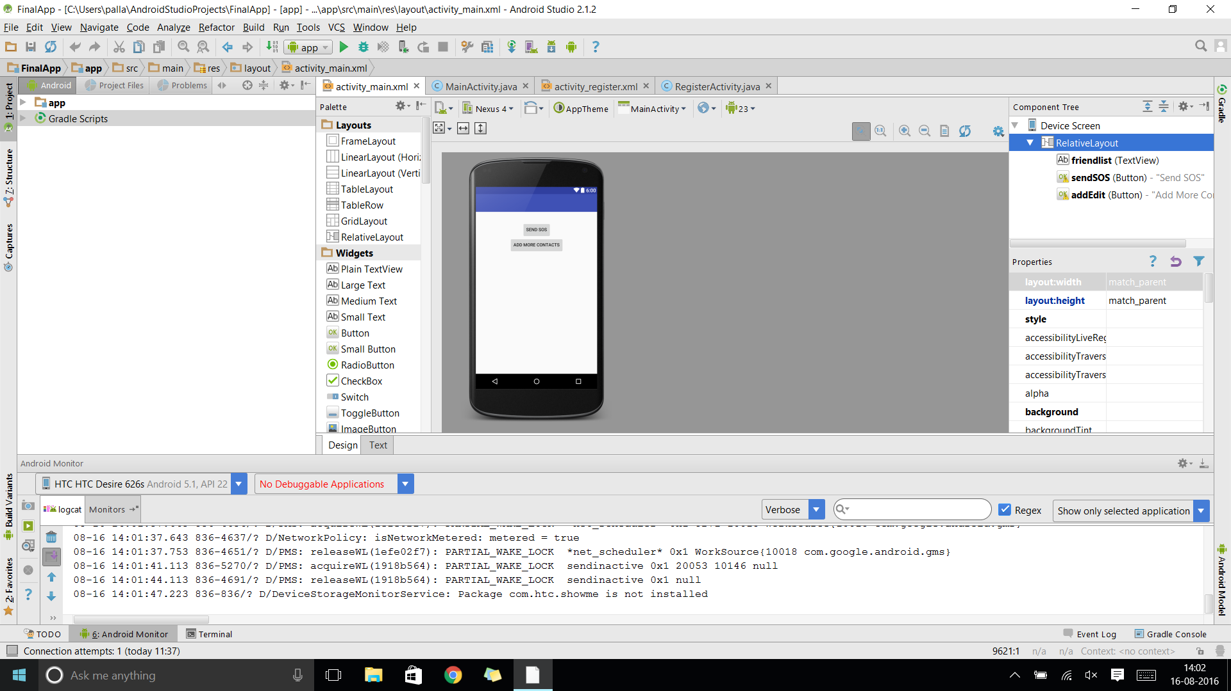

## MODULE 2: WORKING WITH ANDROID WIDGETS FOR USER INTERACTION

Widgets are the User Interface elements that allow users to interact with the application. These are typically used for IO functions. The following are the most commonly used widgets:

### Button

Buttons can be used for a variety of purposes, typical usages being initiation of functions and intents. Listeners are the most common methods used to provide IO functionalities.

Buttons can be programmatically created like so:

Button button = new Button(context);

Or they can refer to previously created elements in the layout files like so:

Button button = (Button) findViewById(R.id.button);

Listeners are implemented in the following way:

button.setOnClickListener(new View.OnClickListener() {

public void onClick(View v) {  
                 // Perform action on click  
             });

### TextView

Textviews, as the name suggests, are used to display text. Text within textviews can be formatted to change text color, size, font and are declared in the following way:

Textview textview = new Textview(context);

OR, they can referenced from pre-created elements in the XML files.

### EditText

The EditText widget allows for user input. The type of acceptable inputs can be specified either programmatically or within the XML files. Input types can be specified to limit user input to plain text, numbers only, email fields, passwords, etc. Text from the EditText widget can be accessed in the following way:

String string = editText.getText().toString();

### ImageView

The ImageView class can load images from internal application resources, device resources or URLs (if connected to the internet). The setImageResource method allows you to add images to the ImageView but resource ID or bitmaps or drawables. For example:

imageview.setImageResource(resId);

imageview.setImageBitmap(bitmap);

imageview.setImageDrawable(drawable);

### Toast

Toast messages can be thought of as “volatile” popup notifications that appear on the screen, typically used for feedback. They are created and displayed in the following way:

Toast toast = Toast.makeText(context, "My Message", durationOfToast);  
toast.show();

### *Assignment 1*

*Create an application that accepts a string input from a user (stating a color) and displays that color in an ImageView. The first activity must consist of two fragments, one containing an EditText and the other containing a “Show Color” button. The second activity must contain an ImageView that displays the color.*

*Approach:*

1. *Create a new project that consists of two activities and two fragments.*
2. *Incorporate the two fragments within the first activity.*

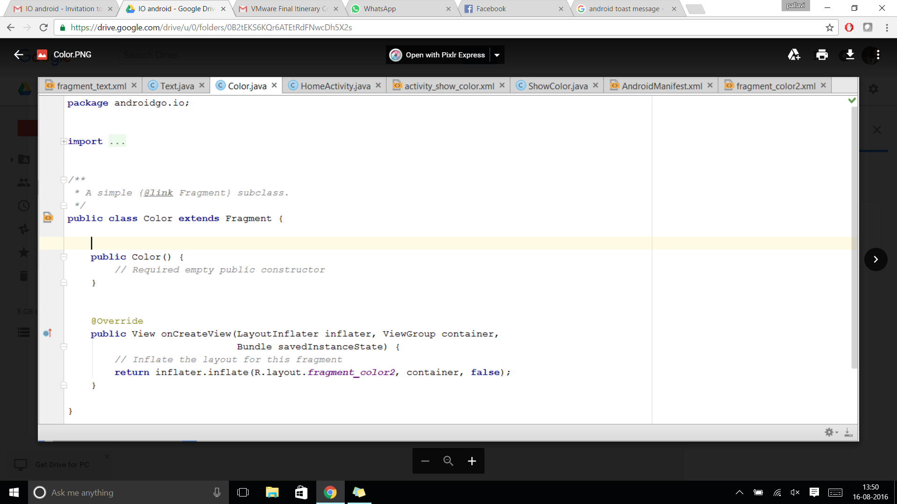

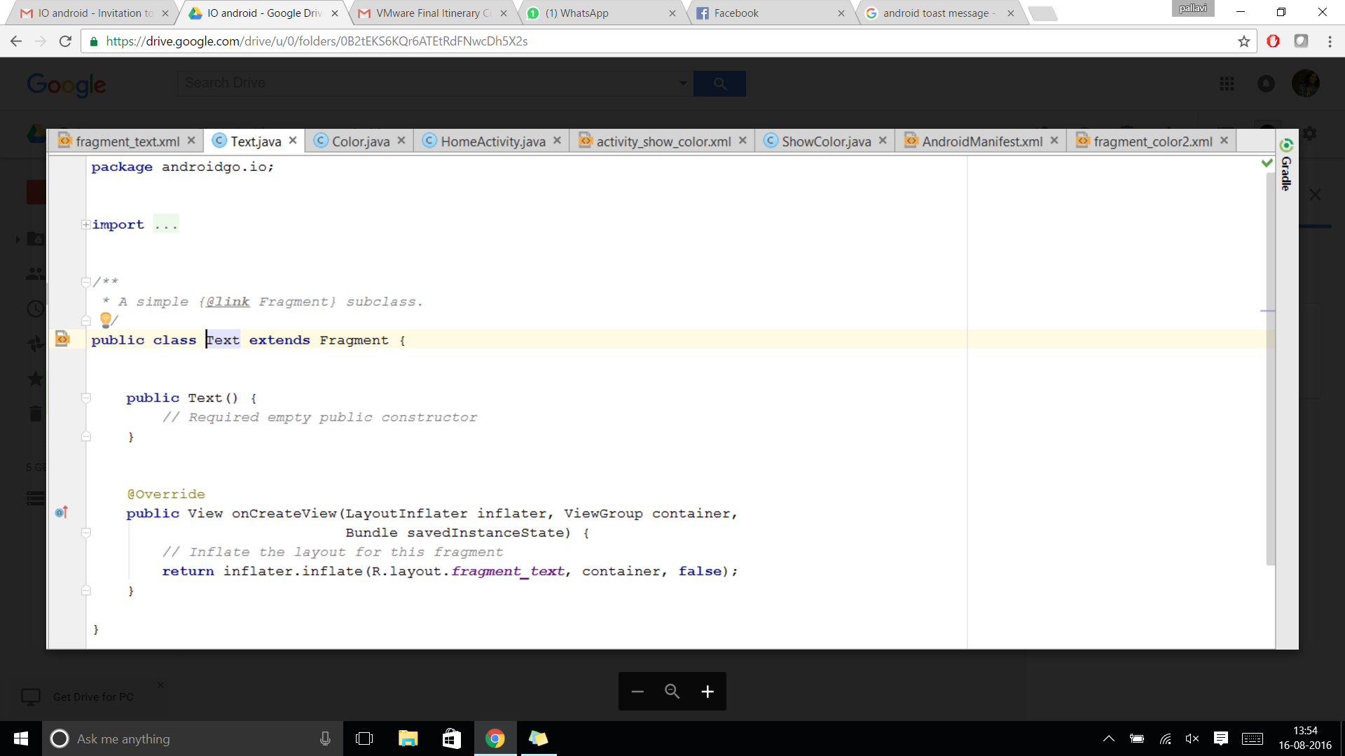

1. *Declare all required variables.*
2. *Add an EditText to one fragment and a Button to the other fragment. These widgets can be found in the graphical interface of the respective layout XML files.*
3. *Use an Intent in the onClickListener of the button to switch to the second activity. Bind the user input from the EditText to this intent.*

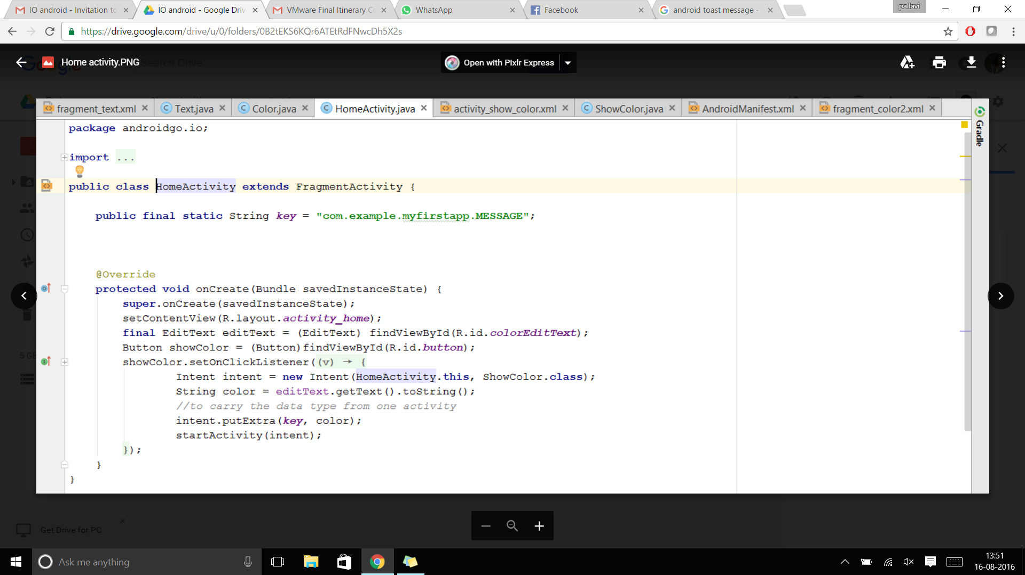

1. *Add an ImageView to the second activity.*
2. *Set the background of the ImageView to the color entered by the user.*

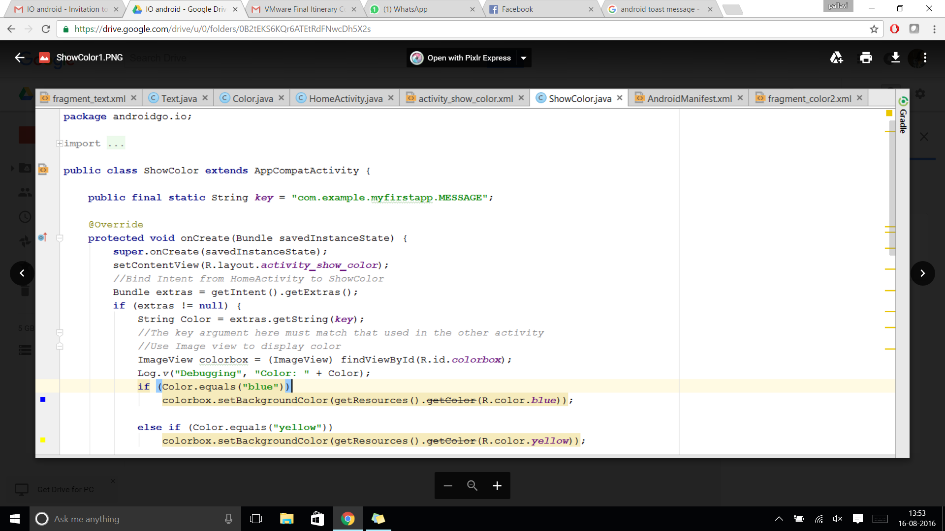

## MODULE 3: COMMUNICATION

This module describes how to build an app with capabilities for communication, say for example, for the purpose of sending an SMS. They key point with regard to building connected apps is providing the right permissions that allow for communication. As discussed earlier, permissions can be modified within the Manifest file.

### Sending an SMS:

1. To send an SMS in Android, we use the SMSManager API.
2. To get its object we use the static method getDefault().
3. Following is the syntax to send an SMS:

SmsManager manager = SmsManager.getDefault();

manager.sendDataMessage([String](https://developer.android.com/reference/java/lang/String.html) destinationAddress, [String](https://developer.android.com/reference/java/lang/String.html) scAddress, short destinationPort, byte[] data,[PendingIntent](https://developer.android.com/reference/android/app/PendingIntent.html) sentIntent, [PendingIntent](https://developer.android.com/reference/android/app/PendingIntent.html) deliveryIntent)

### Creating and Saving a File to External Storage:

1. The FileWriter API is used to write characters to a file.
2. Following is the syntax of creating a File:

FileWriter fileWriter = new FileWriter(File file, Boolean append); // Create a FileWriter Object from a File object and a boolean set to true if you want to allow appending to the file

fileWriter.append(char c); //appends the character to the FileWriter object

fileWriter.close(); // close the FileWriter object

### Granting Permissions to your Android Application:

To grant permissions to access protected features like sending an SMS or reading/writing external storage, we need to update the AndroidManifest.xml file

<uses-permission android:name="android.permission.SEND_SMS"/>  
<uses-permission android:name="android.permission.READ_EXTERNAL_STORAGE" />  
<uses-permission android:name="android.permission.WRITE_EXTERNAL_STORAGE"/>

### *Assignment 2*

*Create a messaging application that sends a given text message to the phone number provided and also saves the phone number and the text message to a log file stored in external storage.*

*Approach:*

1. *Create a new project that consists of one main activity.*
2. *Declare all required variables.*
3. *Add an EditText widgets to enter a phone number and the message and a SEND button.*
4. *Set up the SMS Manager to handle communication.*

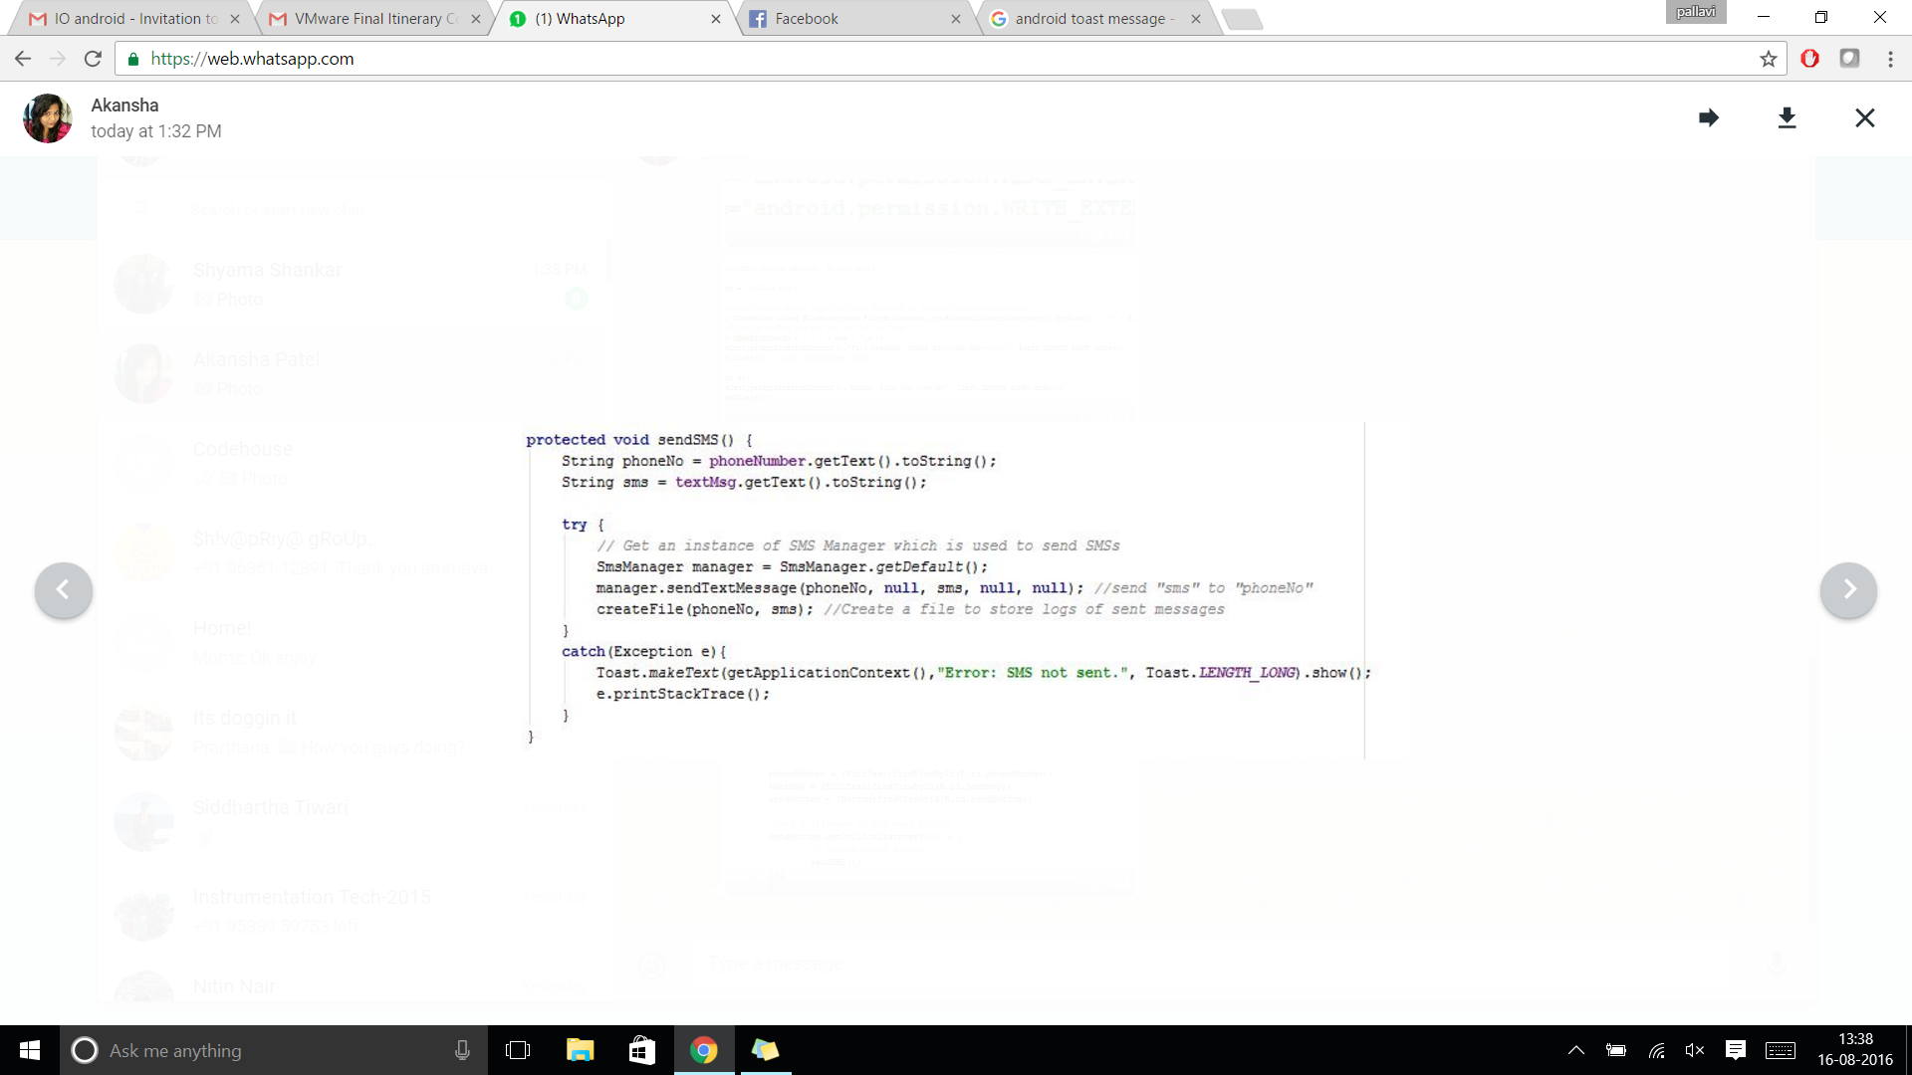

1. *Set up FileIO to maintain a log of the messages sent.*

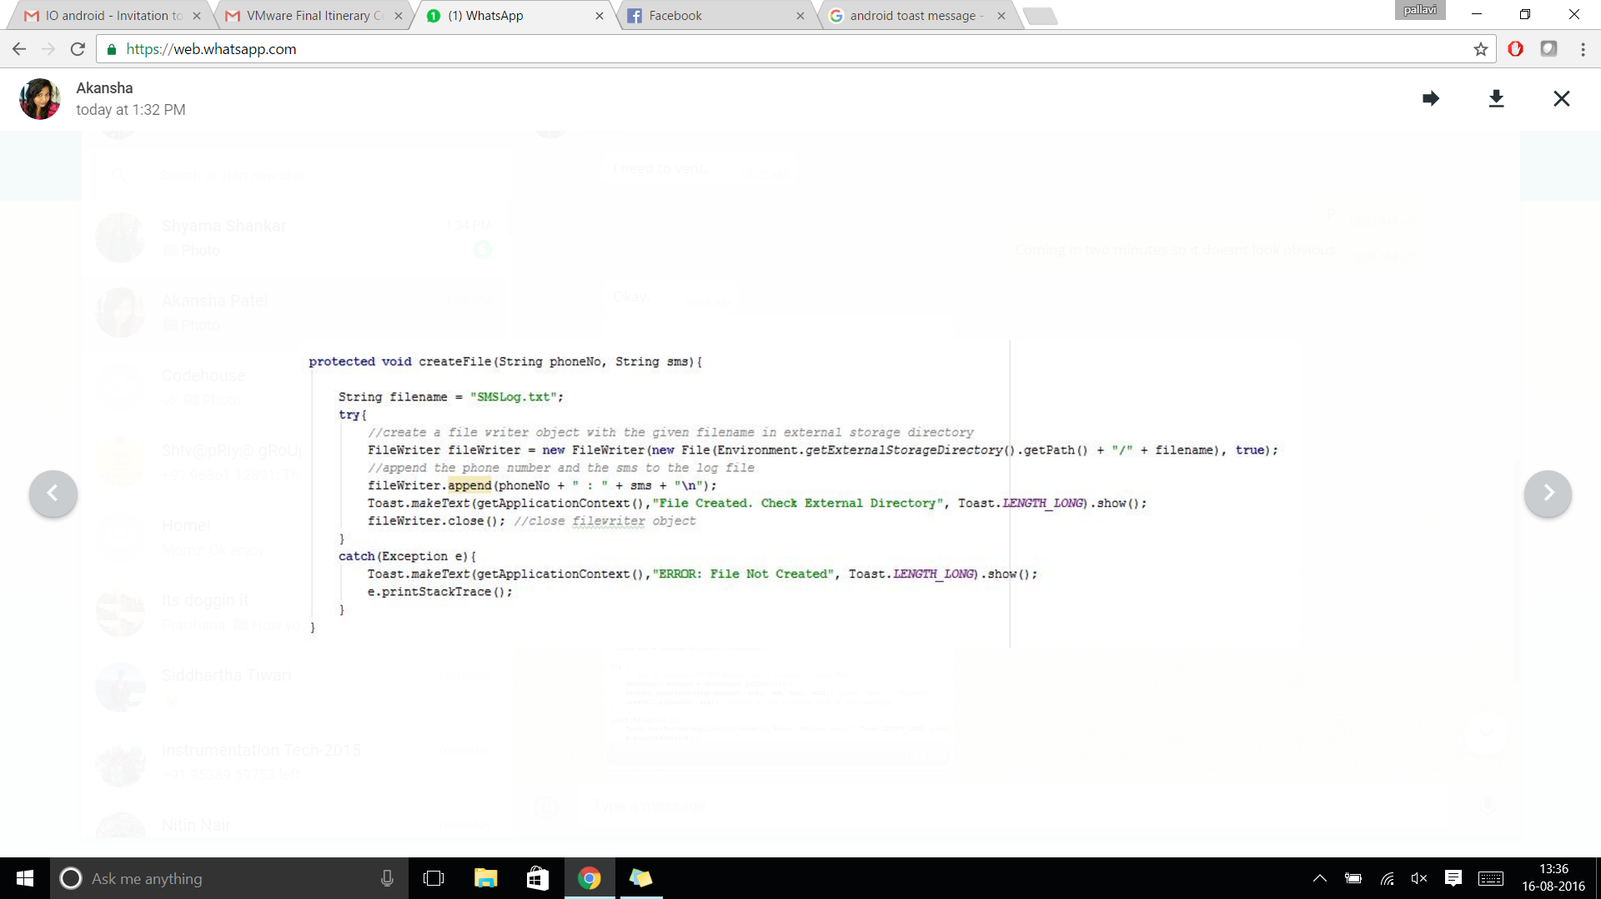

1. *Use an onClickListener to send the SMS and write to the log file when the SEND button is clicked.*

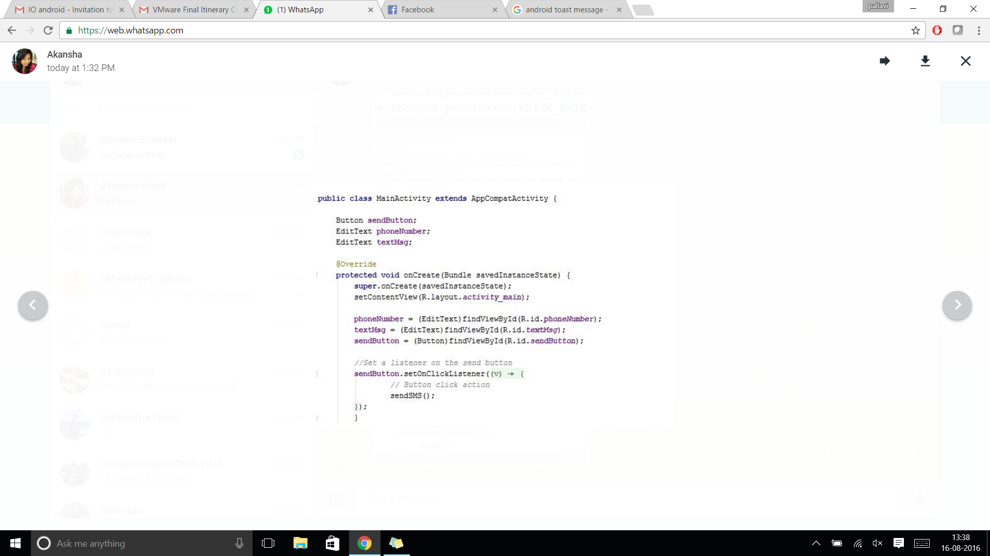

1. *Remember to add permissions in your Manifest file!*

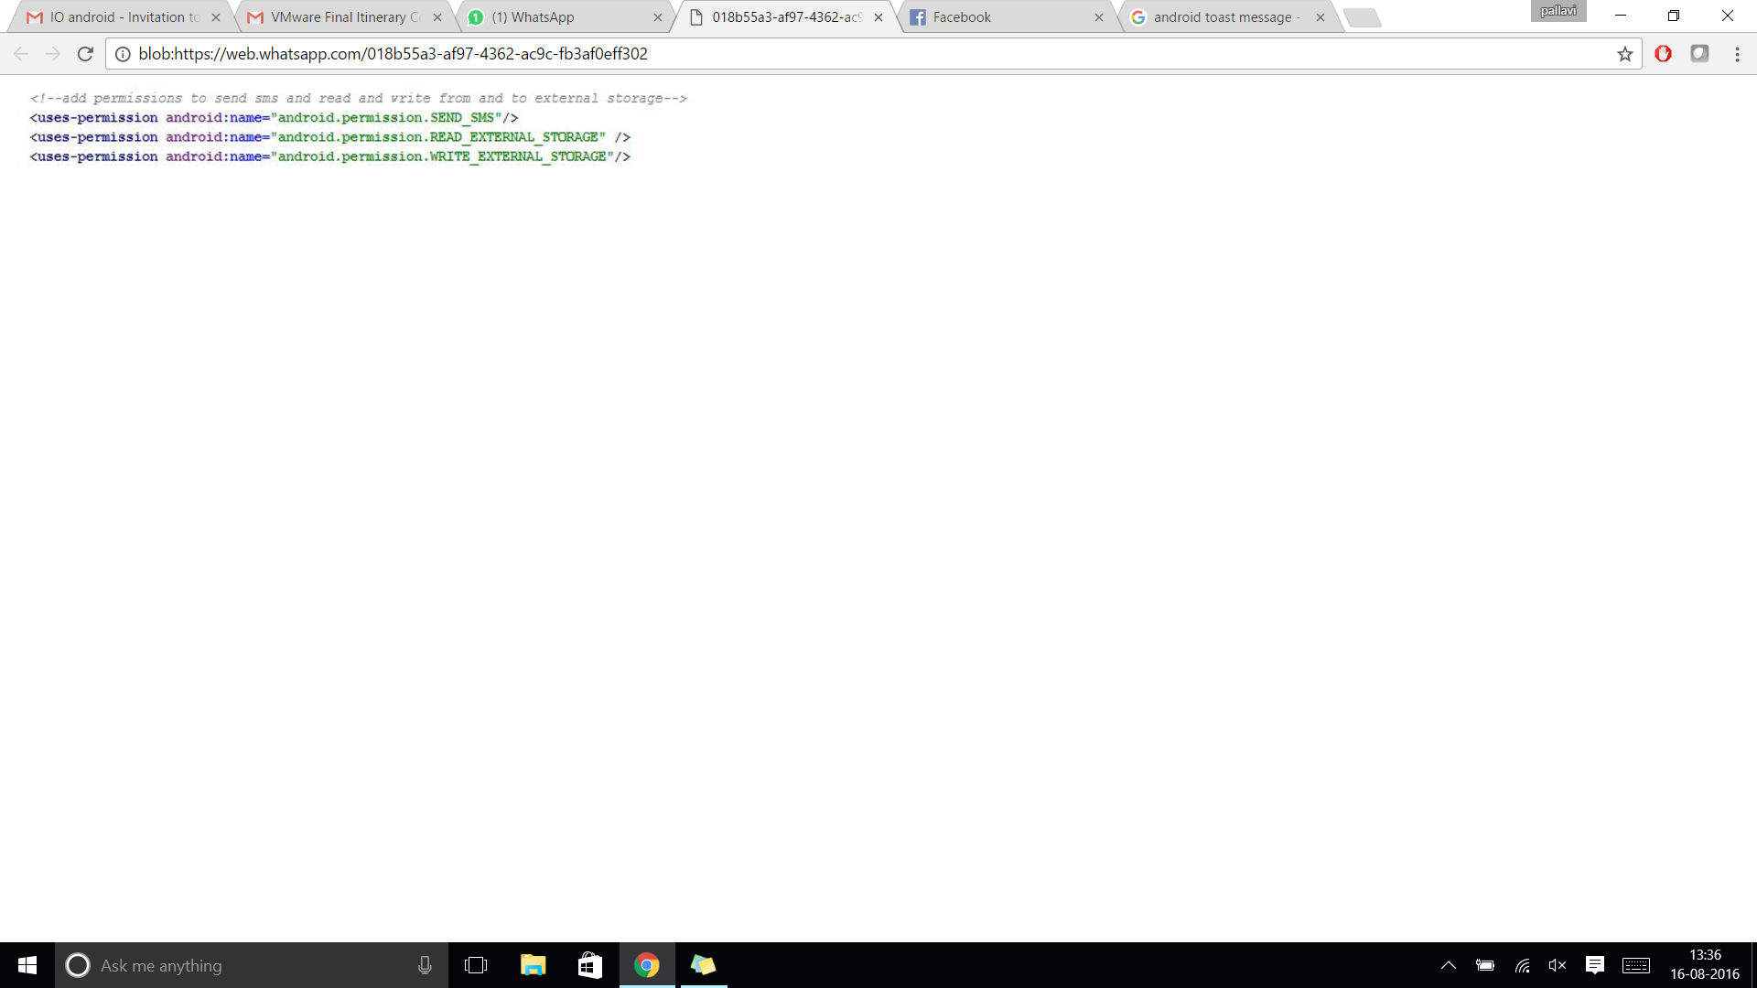

## MODULE 4: STORING YOUR DATA

Data storage and retrieval is an important part of application development. The simplest way to create a private database in Android is to use SQLite. All Android devices come with SQLite integrated in them and no additional installations or set-up is required to use it. The classes that implement SQLite operations are available in the android.database.sqlite package.

### Creating database and tables

* Extend the SQLiteOpenHelper class.
* The database tables can be created inside the onCreate method of this class.

private static final String CREATE_QUERY = "CREATE TABLE contacts (contact_id INTEGER PRIMARY KEY AUTOINCREMENT, contact_name TEXT, phone_number NUMERIC);";

public ContactsDbOpenHelper(Context context, String name, SQLiteDatabase.CursorFactory factory, int version) {

super(context, name, factory, version);

}

@Override

public void onCreate(SQLiteDatabase db) {

db.execSQL(CREATE_QUERY);

}

:

:

}

* The database gets created when we create an object of this class:

ContactsDbOpenHelper databaseOpenHelper = new ContactsDbOpenHelper(context, DATABASE_NAME, null, 1);

### Open the database:

Open for writing:

SQLiteDatabase database = databaseOpenHelper.getWritableDatabase();

Open for reading:

SQLiteDatabase database = databaseOpenHelper.getReadableDatabase();

### Close the database

database.close();

### Insert data

// Use ContentValues to hold the data to be inserted

ContentValues newData = new ContentValues();

newData.put(COLUMN_NAME_1, "first_bit_of_data");

newData.put(COLUMN_NAME_2, "second_bit_of_data");

// Open the database, insert data and then close it

database = databaseOpenHelper.getWritableDatabase();

database.insert(TABLE_NAME, null, newData);

database.close();

### Read data

*// Read one contact information from the database*

*String selectquery = "SELECT * from "+ TABLE_NAME + ";";*

*Cursor cursor = database.rawQuery(selectquery, null);*

*String data1 = "", data2 = "";*

*if (cursor.moveToFirst()) {*

*data1 = cursor.getString(1);*

*data2 = cursor.getString(2);*

*}*

### *Assignment 3*

*Create an application that allows the users to save and retrieve contacts information (name and phone number). Implement a SQLite database with a basic table that includes columns name and phone number.*

*Approach:*

1. *Create a new project that consists of one main activity.*
2. *Declare all required variables.*
3. *Add an EditText widgets to enter contact details, a SAVE button and a TextView to display data retrieved from the database.*

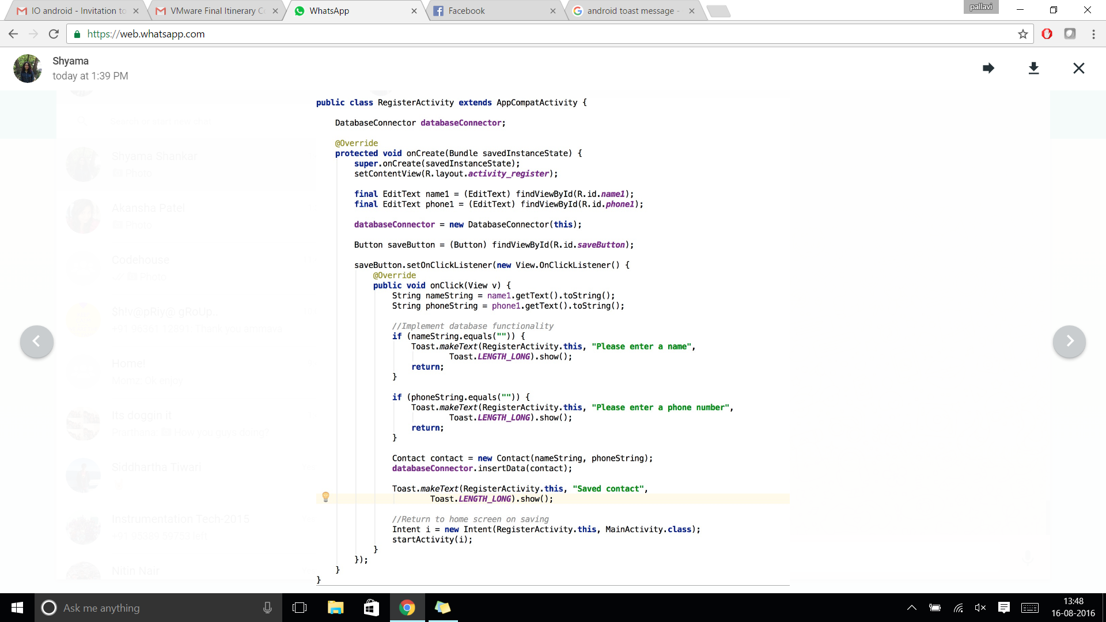

1. *Initialize the database and create the relevant tables.*

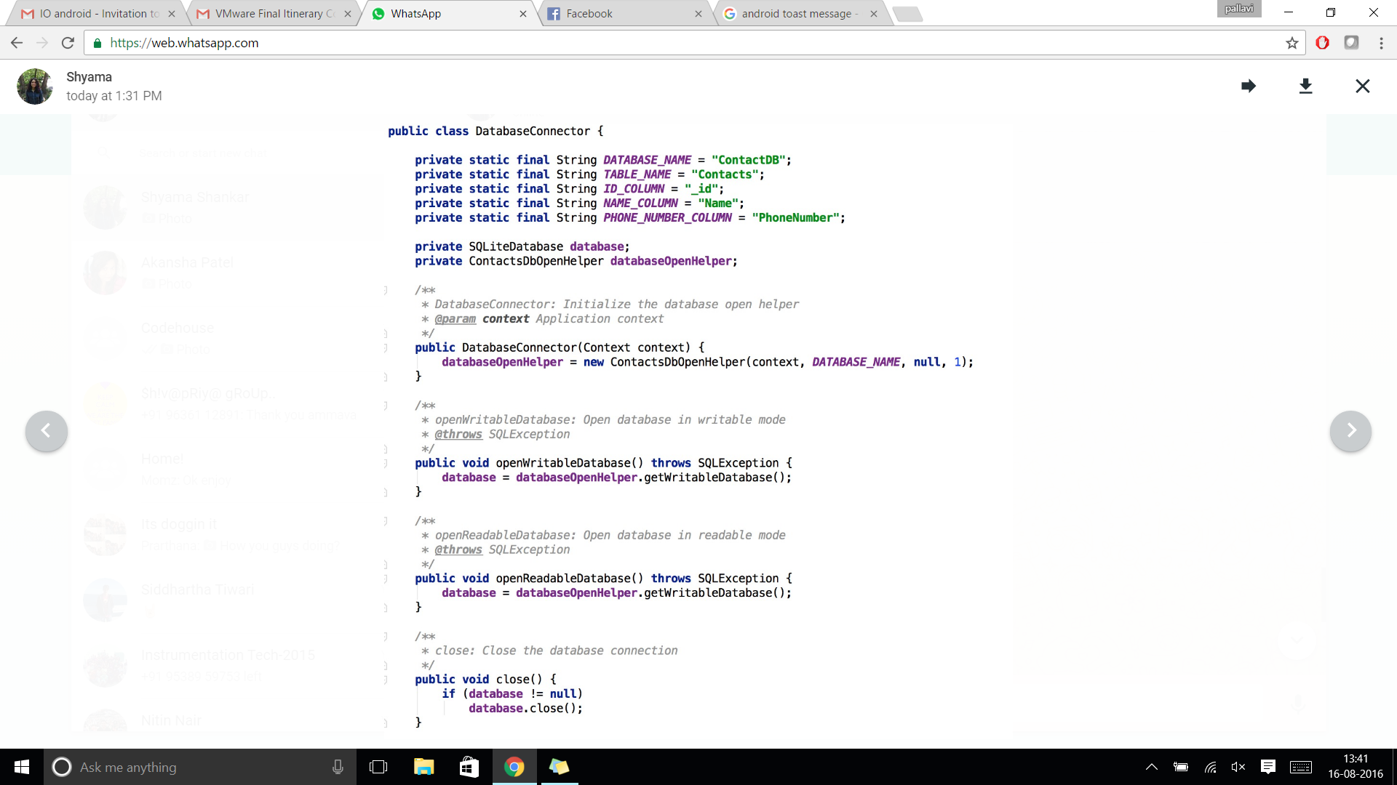

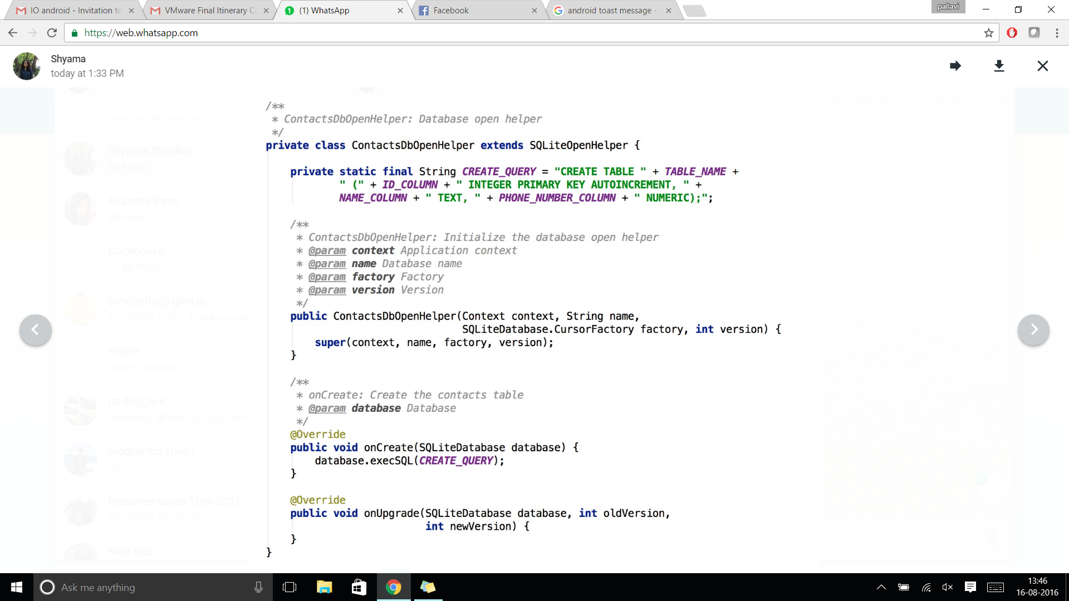

1. *Implement the CRUD operations.*

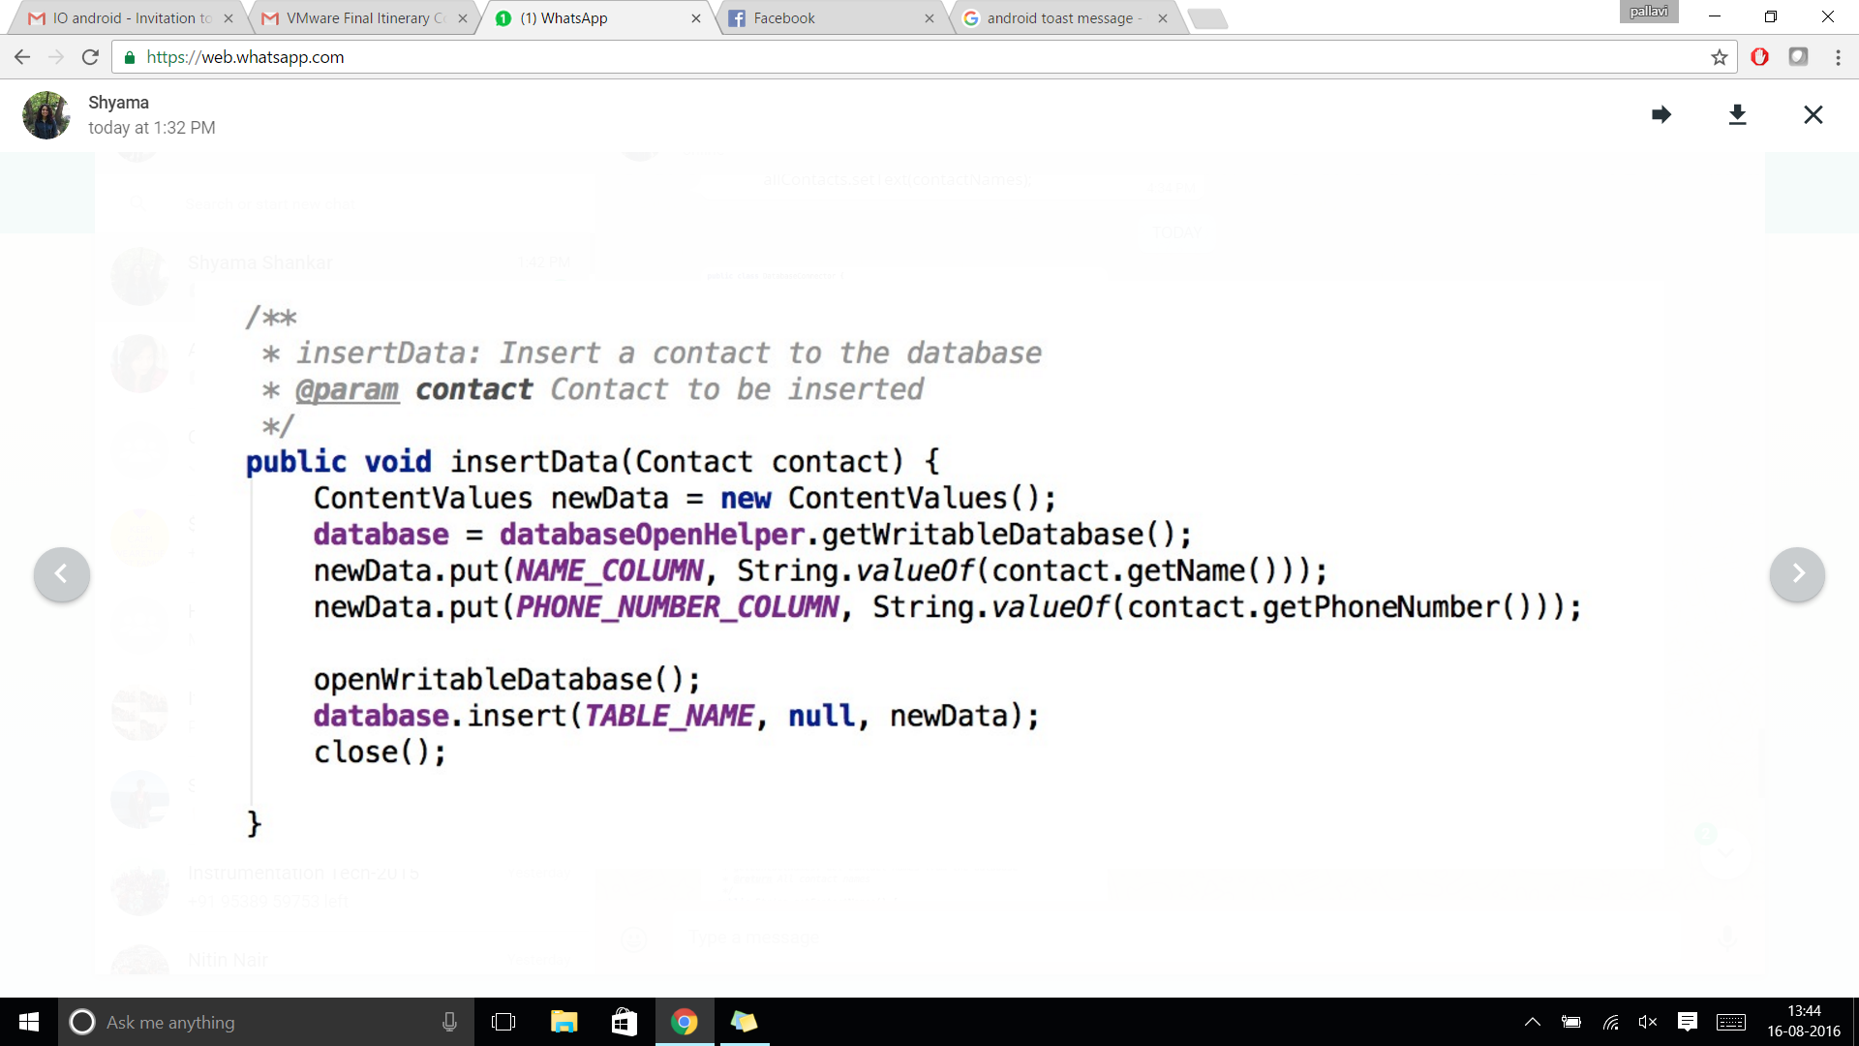

1. *Use an onClickListener to save a contact to the database when the SAVE button is clicked.*



1. *Read data from the database and display in the TextView.*

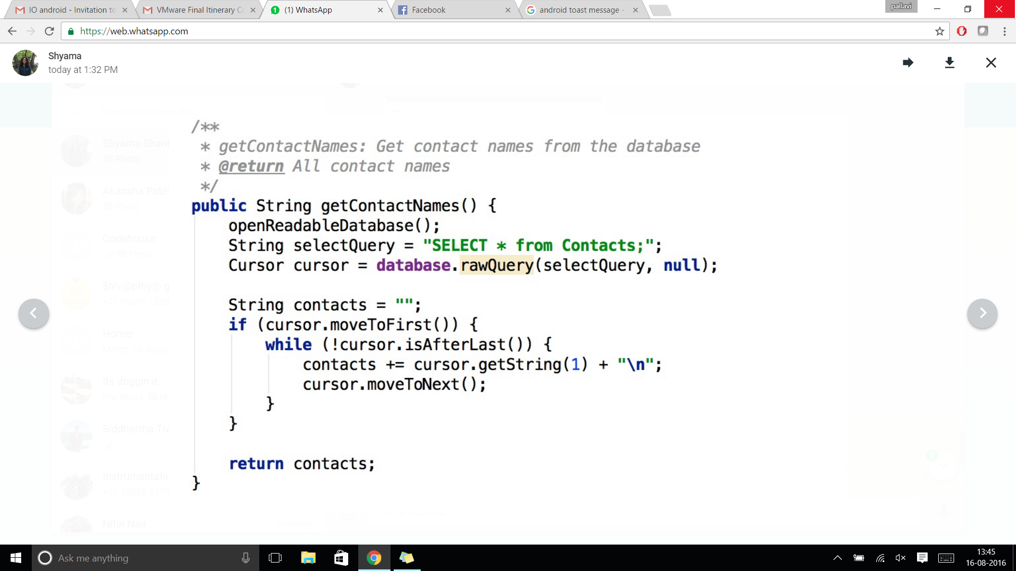

## MODULE 5: DESIGNING APPS THAT RUN IN THE BACKGROUND- SERVICES

Services are applications that provide functionalities that run in the background and do not consist of a tangible UI. Services are similar to activities, barring the UI. They are declared separately within the Android Manifest and are required to extend from the Service class.

The onCreate() method for services are identical to their activity counter-parts. Additionally, other applications can “bind” to a service using the onBind() method. This allows applications to interact with the service, send requests and receive results.

### *Assignment 4*

*Create an application that works in the background to calculate the user’s location (latitude and longitude) and displays the same via a Toast message on the device’s home screen.*

*Approach:*

1. *Create a new project with an activity and a service.*
2. *The onCreate() method of the activity is invoked when the app is started from the device. Here, we remove the bit of code that we generally use to associate a layout file with an activity.*
3. *Start the service using the startService() call.*

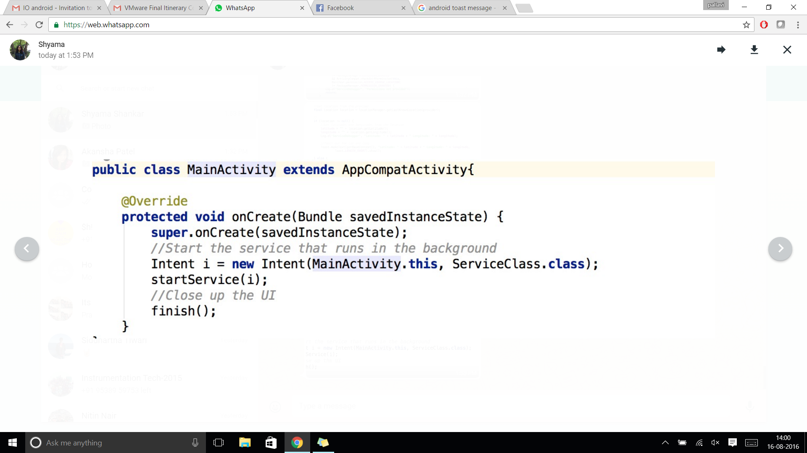

1. *Within the service, use the Location manager to obtain the GPS location of the device.*

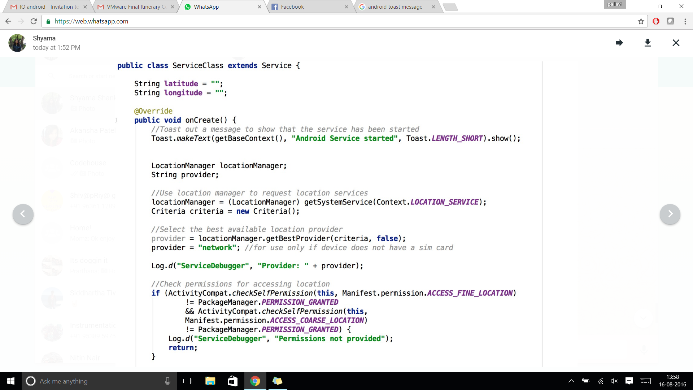

1. *Toast messages to the homescreen while the compute happens in the background.*

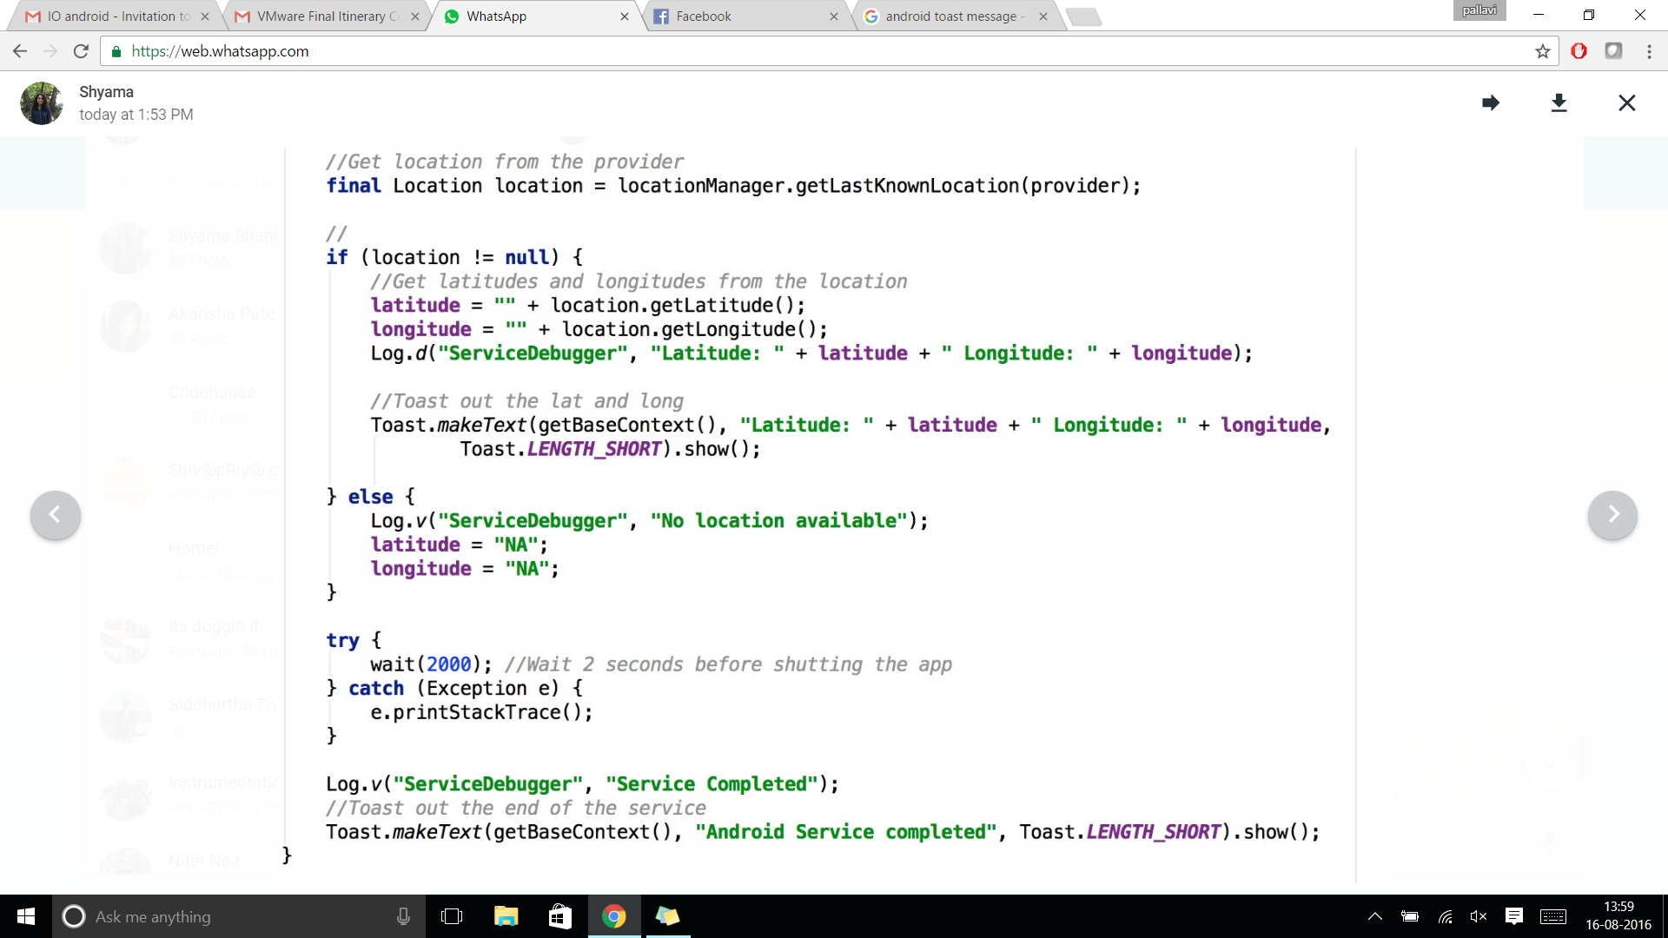

## MODULE 6: “Save My Soul”: BUILD YOUR OWN SOS APPLICATION

In this module, you will learn to build an end-to-end application (that actually serves a purpose!) implementing most of the modules discussed previously.

*Problem Statement: Create an Android application that allows users to send SOS messages in times of need to a set of (emergency) contacts. The application, on the first run, must prompt the user to enter at least one contact, details of which are stored in a local SQLite database. During a crisis (of any kind) the user must be able to open the app and click one button that sends an SOS message, consisting of the user’s location, to all the contacts that were defined previously. The process of calculating location and sending SMSs must occur in a background service. Additionally, the user must also be able to add new contacts whenever he/she desires.*

### Approach

1. Decide on the number of activities and the types on IO widgets on each activity.
2. Determine if the application is being launched for the first time, in which case, redirect to the activity that accepts contact details.
3. Implement database functions to add contact details to a SQLite database.
4. Implement methods to calculate the GPS location and send and SMS. Combine these methods into a Service.
5. Run a loop that calls the service until a message is sent to each contact.

### Extra credit

1. Implement methods to prevent the user from entering the same contact twice.
2. Implement methods to allow updating/deletion of an existing contact.
3. Implement error handling techniques so that your application never crashes.
4. Use formatting styles (resources in the appendix) to make your app stylish!

## RESOURCES

1. Installation: <https://developer.android.com/studio/install.html>
2. Use this to build colorful apps! <https://developer.android.com/reference/android/graphics/Color.html>
3. Add style to your text! <https://guides.codepath.com/android/Working-with-the-TextView>
4. If your device runs Android 6.0 (or above), use this to handle permissions at runtime. <https://developer.android.com/training/permissions/requesting.html>
5. All you need to know about connecting your application to the Cloud <https://developer.android.com/training/building-connectivity.html>
6. Be efficient with resources: <https://developer.android.com/training/best-performance.html>